[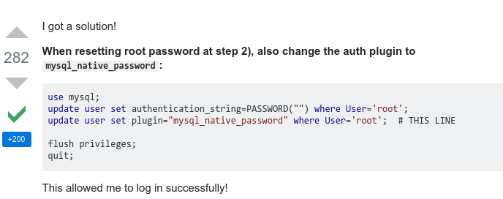](https://stackoverflow.com/questions/37879448/mysql-fails-on-mysql-error-1524-hy000-plugin-auth-socket-is-not-loaded/37879449#37879449?newreg=e39f3cc3b9e8431abc5082743af163c5)

